Cloud Migration

By: Kavan Dalwadi

# Why should we migrate to CLOUD?

The decision to migrate to the cloud can be driven by several factors, including- data center lease expiration, required hardware upgrades, software license renewals, location requirements to meet regulatory compliance, global market expansion, increased developer productivity or the need for a standard architecture.

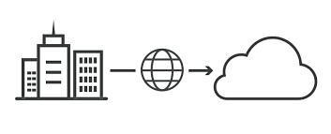

# Let’s understand Migration

Moving a meaningful portion—not necessarily all—of your organization’s existing IT assets to the cloud is considered a “migration.”

A migration might consist of moving a single data center, a collection of data centers or some other portfolio of systems that is larger than a single application.

Cloud migration is sort of like a physical move, except it involves moving data, applications, and IT processes from some data centers to other data centers, instead of packing up and moving physical goods.

Most often, "cloud migration" describes the move from on-premises or legacy infrastructure to the cloud. However, the term can also apply to a migration from one cloud to another cloud.

# What are the main benefits of migrating to the cloud?

* **Scalability:** Cloud computing can scale up to support larger workloads and greater numbers of users far more easily than on-premises infrastructure, which requires companies to purchase and set up additional physical servers, networking equipment, or software licenses.
* **Cost:** Companies that move to the cloud often vastly reduce the amount they spend on IT operations, since the cloud providers handle maintenance and upgrades.
* **Performance:** Moving to the cloud can enable them to improve performance and the overall user experience for their customers. If their application or website is hosted in cloud data centers, then data will not have to travel as far to reach the users, reducing latency.
* **Flexibility:** Users, whether they're employees or customers, can access the cloud services and data they need from anywhere. This makes it easier for a business to expand into new territories, offer their services to international audiences, and let their employees work flexibly.

# What are the main challenges of migrating to the cloud?

* **Lack of Strategy:** Many organizations start migrating to the cloud without devoting sufficient time and attention to their strategy. Each application and dataset may have different requirements and considerations, and may require a different approach to cloud migration.
* **Cost Management:** When migrating to the cloud, many organizations have not set clear KPIs to understand what they plan to spend or save after migration. Cloud environments are dynamic and costs can change rapidly as new services are adopted and application usage grows.
* **Vendor Lock-In:** Vendor lock-in is a common problem for adopters of cloud technology. Cloud providers offer a large variety of services, but many of them cannot be extended to other cloud platforms. Many organizations start using cloud services, and later find it difficult to switch providers if the current provider doesn't suit their requirements.
* **Data Security and Compliance:** One of the major obstacles to cloud migration is data security and compliance. The migration process itself presents security risks. Transferring large volumes of data, which may be sensitive, and configuring access controls for applications across different environments, creates significant exposure.

# Cloud Migration Strategies (The 6 R’s) :

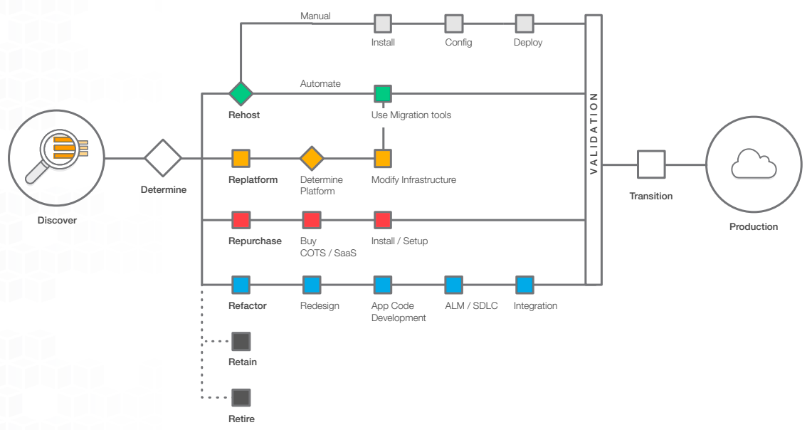

**1. REHOST**

Also known as “lift-and-shift.” In a large legacy migration scenario where the organization is looking to implement its migration and scale quickly to meet a business case, we find that the majority of applications are rehosted.

Most rehosting can be automated with tools such as AWS Server Migration Service (SMS), although some customers prefer to do this manually as they learn how to apply their legacy systems to the new cloud platform. It has also become evident that applications are easier to optimize/re-architect once they are already running in the cloud.

**2. REPLATFORM**

Sometimes referred to as “lift-tinker-and-shift.” This entails making a few cloud optimizations in order to achieve some tangible benefit, without changing the core architecture of the application.

For example, you may be looking to reduce the amount of time you spend managing database instances, so you move to a database-as-a-service offering like Amazon Relational Database Service (Amazon RDS).

**3. REPURCHASE**

Replacing your current environment, casually referred to as “drop and shop.” This is a decision to move to a newer version or different solution, and likely means your organization is willing to change the existing licensing model it has been using. For workloads that can easily be upgraded to newer versions, this strategy might allow a feature set upgrade and smoother implementation.

**4. REFACTOR / RE-ARCHITECT**

Changing the way the application is architected and developed, usually done by employing cloud-native features. Typically, this is driven by a strong business need to add features, scale, or improve performance that would otherwise be difficult to achieve in the application’s existing environment.

If your organization is looking to boost agility or improve business continuity by moving to a service oriented architecture (SOA) this strategy may be worth pursuing—even though it is often the most expensive solution.

**5. RETIRE**

Decommission or archive unneeded portions of your IT portfolio. Identifying IT assets that are no longer useful and can be turned off will help boost your business case, and direct your team’s attention toward maintaining the resources that are widely used.

**6. RETAIN**

Do nothing, for now—revisit. Organizations retain portions of their IT portfolio because there are some that they are not ready to migrate and feel more comfortable keeping them on-premises, or they are not ready to migrate an application that was recently upgraded and then make changes to it again.

You should only migrate what makes sense for the business, but the more your portfolio moves to the cloud, the fewer reasons you will have to retain.

# Cloud Migration Process:

There is no one-size fits all solution to deciding on the best approach. Every business has different needs and will therefore follow a slightly different process for cloud migrations.

Cloud providers can help businesses set up their migration process. Most cloud migrations will include these basic steps:

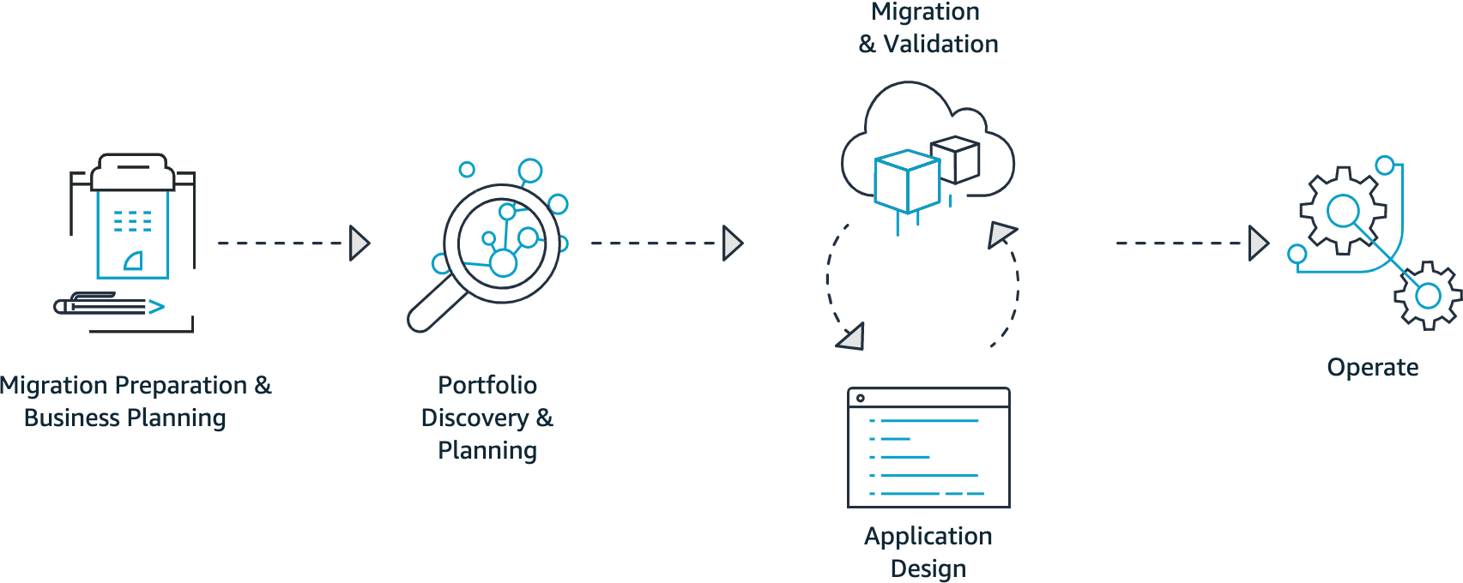

**PHASE 1: MIGRATION PREPARATION AND BUSINESS PLANNING**

The first phase of any migration should involve developing a clear picture of your current operations, business goals, and expectations for migration. You need to ensure that your expectations are realistic and that migration supports your broader goals.

**PHASE 2: PORTFOLIO DISCOVERY AND PLANNING:**

Once you have determined that migration is the right choice for you, you can begin creating an explicit migration plan. To do this, you need to create an inventory of your current infrastructure, configurations, and assets. Determine how resources are currently being used and what requirements exist and need to be accounted for.

Multiple AWS migration services can help you with this stage. These services can help you evaluate data and applications and provide feedback on migration readiness.

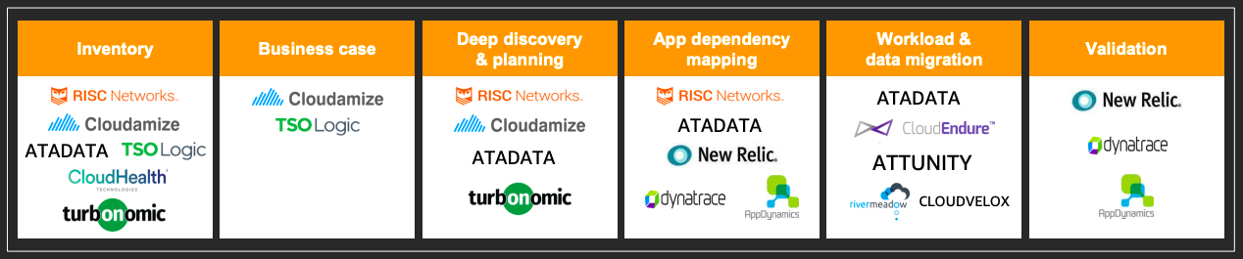

**Migration Tools**

**PHASE 3/ PHASE 4: DESIGNING, MIGRATING, AND VALIDATING APPLICATIONS**

Phase 3 and 4 may be performed as distinct phases or may be combined, depending on your migration strategy. The focus shifts from the portfolio level to the individual application level. Each application is designed, migrated, and validated according to one of the six common migration strategies (“The 6 R’s”).

Commonly, organizations start by lifting and shifting less critical applications and data. Then, once applications are in the cloud, teams may return to applications and begin refactoring or architecting application code to make applications more cloud friendly.

**PHASE 5: OPERATIONS**

As applications are migrated, you optimize your new foundation, turn off old systems, and constantly iterate toward a modern operating model. After your migration you also need to carefully monitor your resources and workloads. This is the time when you should be focused on identifying misconfigurations or performance issues and applying corrections.

**Workflow -**

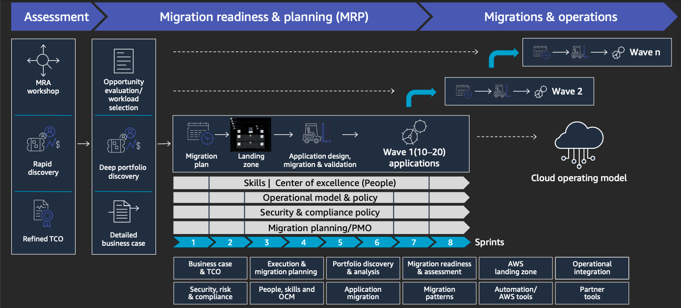

Migration Workflow

# 

AWS Tools for Workflow

# AWS Migration Services:

[AWS Application Discovery Service](https://docs.aws.amazon.com/application-discovery/latest/userguide/what-is-appdiscovery.html)

[AWS Application Migration Service](https://docs.aws.amazon.com/mgn/latest/ug/what-is-application-migration-service.html)

[AWS Server Migration Service](https://docs.aws.amazon.com/server-migration-service/latest/userguide/server-migration.html)

[AWS Database Migration Service](https://docs.aws.amazon.com/dms/latest/userguide/Welcome.html)

[AWS Schema Conversion Tool](https://docs.aws.amazon.com/SchemaConversionTool/latest/userguide/CHAP_Welcome.html)

[AWS Migration Hub](https://docs.aws.amazon.com/migrationhub/latest/ug/whatishub.html)

[AWS VM Import/Export](https://docs.aws.amazon.com/vm-import/latest/userguide/what-is-vmimport.html)

[AWS CloudEndure](https://docs.aws.amazon.com/prescriptive-guidance/latest/migration-cloudendure/welcome.html)

[AWS DataSync](https://docs.aws.amazon.com/datasync/latest/userguide/what-is-datasync.html)

[AWS Snow Family](https://docs.aws.amazon.com/snowball/?id=docs_gateway)

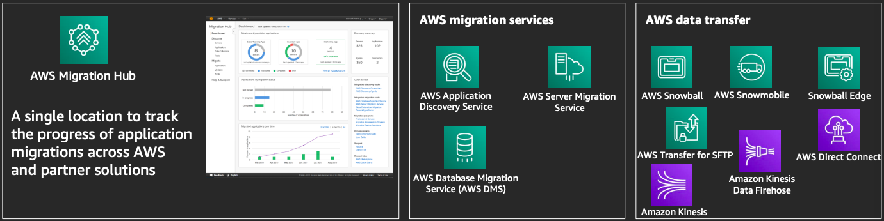

AWS Application Discovery Service - 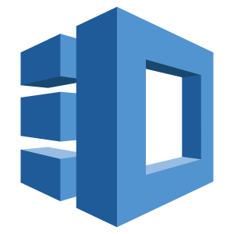

AWS Application Discovery Service helps you plan your migration to the AWS cloud by collecting usage and configuration data about your on-premises servers. You can view the discovered servers, group them into applications, and then track the migration status of each application from the Migration Hub console in your home region.

All discovered data is stored in your AWS Migration Hub home region. Therefore, you must set your home region in the Migration Hub console or with CLI commands before performing any discovery and migration activities.

Application Discovery Service offers two ways of performing discovery and collecting data about your on-premises servers:

* **Agentless** discovery can be performed by deploying the AWS Agentless Discovery Connector (OVA file) through your VMware vCenter. After the Discovery Connector is configured, it identifies virtual machines (VMs) and hosts associated with vCenter. The Discovery Connector collects the following static configuration data: Server hostnames, IP addresses, MAC addresses, disk resource allocations. Additionally, it collects the utilization data for each VM and computes average and peak utilization for metrics such as CPU, RAM, and Disk I/O.
* **Agent-based** discovery can be performed by deploying the AWS Application Discovery Agent on each of your VMs and physical servers. The agent installer is available for Windows and Linux operating systems. It collects static configuration data, detailed time-series system-performance information, inbound and outbound network connections, and processes that are running.

Application Discovery Service is integrated with AWS Migration Hub, which simplifies your migration tracking as it aggregates your migration status information into a single console.

AWS Application Migration Service (MGN) -

AWS Application Migration Service (MGN) is a highly automated lift-and-shift (rehost) solution that simplifies, expedites, and reduces the cost of migrating applications to AWS. It enables companies to lift-and-shift a large number of physical, virtual, or cloud servers without compatibility issues, performance disruption, or long cutover windows. MGN replicates source servers into your AWS account.

When you’re ready, it automatically converts and launches your servers on AWS so you can quickly benefit from the cost savings, productivity, resilience, and agility of the Cloud.

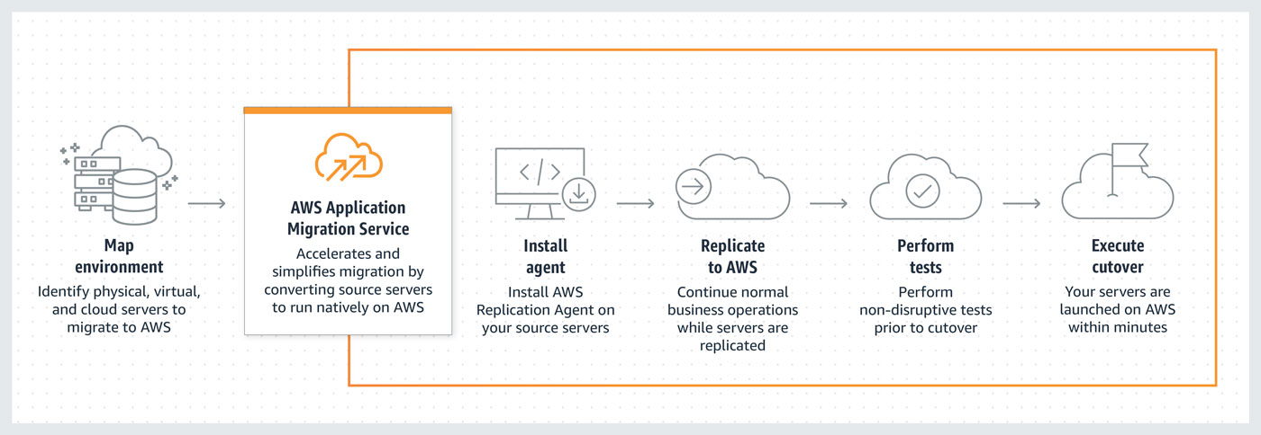

Application Migration Service allows you to launch Test and Cutover instances in AWS. Prior to launching instances, you must configure your Launch settings. Launch settings determine how your Test and Cutover instances will be launched in AWS.

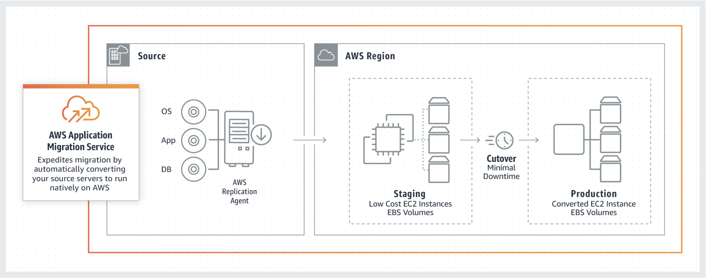

AWS Server Migration Service (SMS) - 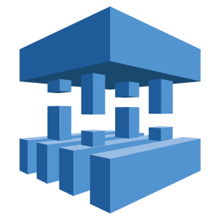

AWS Server Migration Service (AWS SMS) automates the migration of your on-premises VMware vSphere, Microsoft Hyper-V/SCVMM, and Azure virtual machines to the AWS Cloud. AWS SMS incrementally replicates your server VMs as cloud-hosted Amazon Machine Images (AMIs) ready for deployment on Amazon EC2. Working with AMIs, you can easily test and update your cloud-based images before deploying them in production.

By using AWS SMS to manage your server migrations, you can:

* Begin by migrating a group of servers using the AWS CLI. AWS SMS manages all the complexities of the migration process, including automatically replicating volumes of live servers to AWS and creating new AMIs periodically.
* AWS SMS orchestrates multiple server migrations by allowing you to schedule replications and track progress of a group of servers that constitutes an application.
* Test server migrations incrementally: With support for incremental replication, AWS SMS allows fast, scalable testing of migrated servers.
* Support the most widely used operating systems. Minimize downtime. Incremental AWS SMS replication minimizes the business impact associated with application downtime during the final cutover.

| AWS SMS supports the automated migration of multi-server application stacks from your on-premises data center to Amazon EC2. Where server migration is accomplished by replicating a single server as an AMI, application migration replicates all of the servers in an application as AMIs and generates an AWS CloudFormation template to launch them in a coordinated fashion. |  |
| --- | --- |

AWS Database Migration Service - 

AWS Database Migration Service (AWS DMS) is a cloud service that makes it easy to migrate relational databases, data warehouses, NoSQL databases, and other types of data stores. You can use AWS DMS to migrate your data into the AWS Cloud or between combinations of cloud and on-premises setups.

If you want to migrate to a different database engine, you can use the AWS Schema Conversion Tool (AWS SCT) to translate your database schema to the new platform. You then use AWS DMS to migrate the data.

At a basic level, AWS DMS is a server in the AWS Cloud that runs replication software. You create a source and target connection to tell AWS DMS where to extract from and load to. Then you schedule a task that runs on this server to move your data. AWS DMS creates the tables and associated primary keys if they don't exist on the target.

The following diagram illustrates the AWS DMS replication process.

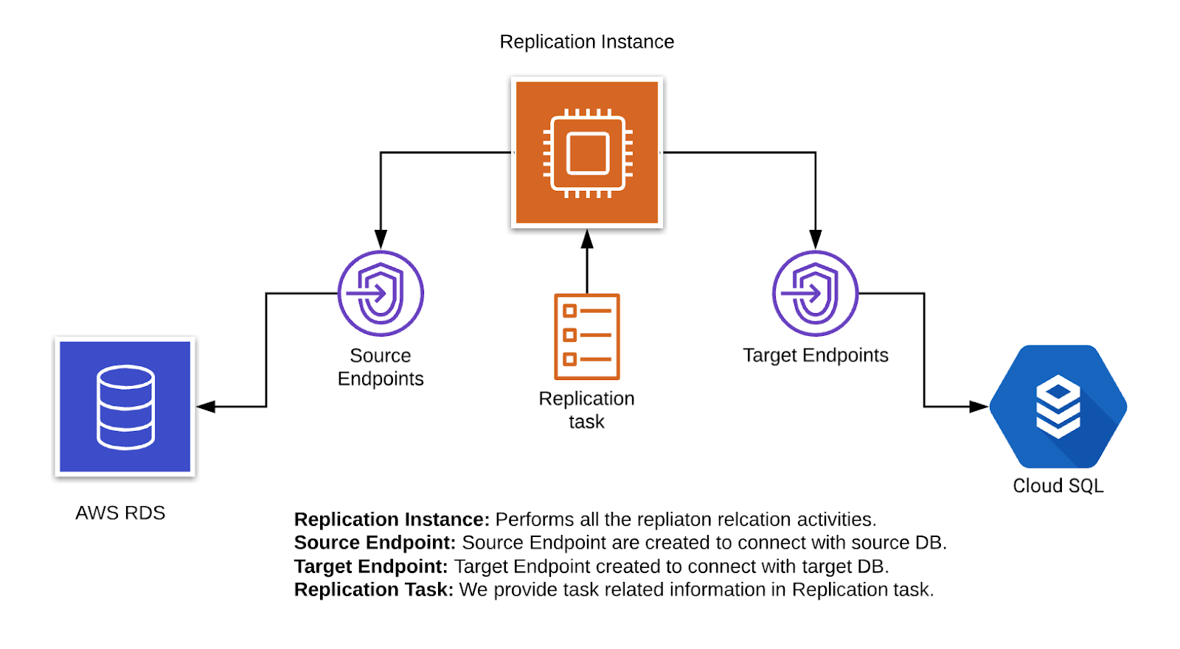

AWS Schema Conversion Tool -

You can use the AWS Schema Conversion Tool (AWS SCT) to convert your existing database schema from one database engine to another. You can convert relational OLTP schema, or data warehouse schema. Your converted schema is suitable for an Amazon Relational Database Service (Amazon RDS) MySQL, MariaDB, Oracle, SQL Server, PostgreSQL DB, an Amazon Aurora DB cluster, or an Amazon Redshift cluster. The converted schema can also be used with a database on an Amazon EC2 instance or stored as data on an Amazon S3 bucket.

AWS SCT provides a project-based user interface to automatically convert the database schema of your source database into a format compatible with your target Amazon RDS instance. If schema from your source database can't be converted automatically, AWS SCT provides guidance on how you can create equivalent schema in your target Amazon RDS database.

AWS Schema Conversion Tool (AWS SCT) converts the schema for a source database located either on-premises or hosted by AWS. You can convert your source schema to a schema for any supported database that is hosted by AWS.

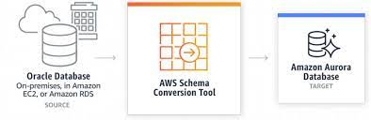

AWS Migration Hub - 

AWS Migration Hub (Migration Hub) provides a single place to discover your existing servers, plan migrations, and track the status of each application migration. The Migration Hub provides visibility into your application portfolio and streamlines planning and tracking. You can visualize the connections and the status of the servers and databases that make up each of the applications you are migrating, regardless of which migration tool you are using.

Migration Hub supports migration status updates from the following tools:

* AWS Application Migration Service (MGN)
* AWS Server Migration Service (SMS)
* AWS Database Migration Service (DMS)

Before migrating you can discover information about your on-premises server and application resources to help you build a business case for migrating or to build a migration plan.

Discovering your servers first is an optional starting point for migrations, gathering detailed server information, and then grouping the discovered servers into applications to be migrated and tracked.

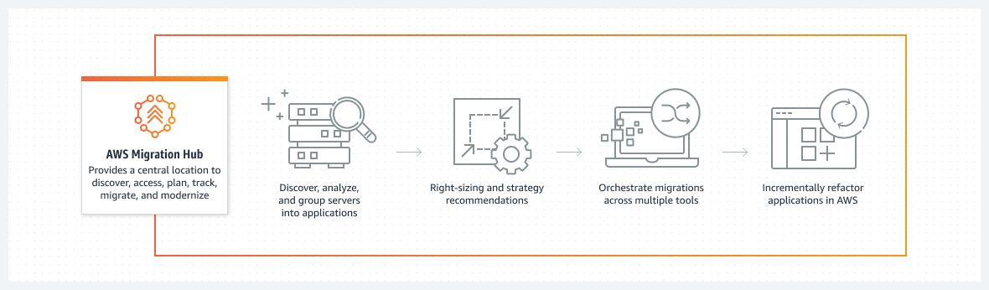

AWS VM Import/Export -

VM Import/Export enables you to import virtual machine (VM) images from your existing virtualization environment to Amazon EC2, and then export them back. This enables you to migrate applications and workloads to Amazon EC2, copy your VM image catalog to Amazon EC2, or create a repository of VM images for backup and disaster recovery.

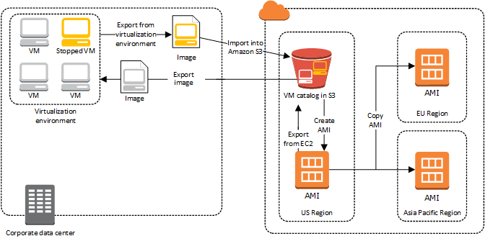

AMI Import

You can import a VM from your virtualization environment to Amazon EC2 as an AMI or as an EC2 instance. The instance is initially in a stopped state. Also export a VM that was previously imported from your virtualization environment. And it has the ability to import disks as Amazon EBS snapshots.

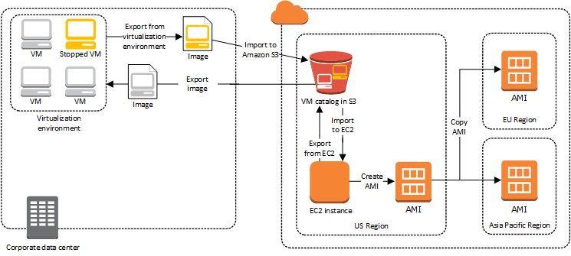

Instance Import

AWS CloudEndure -

CloudEndure Migration is an agent-based tool that rehosts your applications on AWS. It supports self-service, highly automated, lift-and-shift migrations with minimal business disruption. You install the CloudEndure Agent on your source machines. The Agent replicates your applications and data in a staging area on AWS. After the initial replication, the CloudEndure Agent tracks and migrates changes from your source environment to the target staging area by using asynchronous, block-level data replication, without causing downtime or affecting performance.

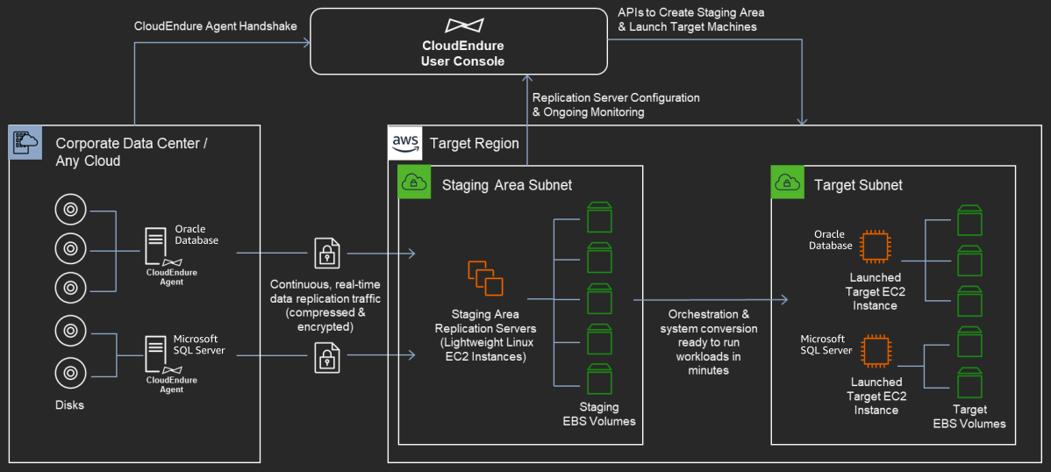

CloudEndure Workflow

| You can use CloudEndure’s self-service, web-based console to configure your target environment, to check for compatibility issues, and to validate that your applications are fully operational on AWS before you cut over. After you rehost your workloads on AWS, you can restructure, rewrite, and re-architect your applications and take advantage of AWS services. |  |
| --- | --- |

AWS DataSync -

AWS DataSync is an online data transfer service that simplifies, automates, and accelerates moving data between storage systems and services.

It is used to move cold data stored in on-premises storage directly to durable and secure long-term storage classes such as S3 Glacier Flexible Retrieval or S3 Glacier Deep Archive. Doing so can free up on-premises storage capacity and shut down legacy systems.

DataSync automates both the management of data-transfer processes and the infrastructure required for high performance and secure data transfer. DataSync provides end-to-end security, including encryption and integrity validation, to help ensure that your data arrives securely, intact, and ready to use. It also supports virtual private cloud (VPC) endpoints, giving you the option to transfer data without traversing the public internet and further increasing the security of data copied online.

DataSync uses a purpose-built network protocol and a parallel, multi-threaded architecture to accelerate your transfers. This approach speeds up migrations, recurring data-processing workflows for analytics and machine learning, and data-protection processes.

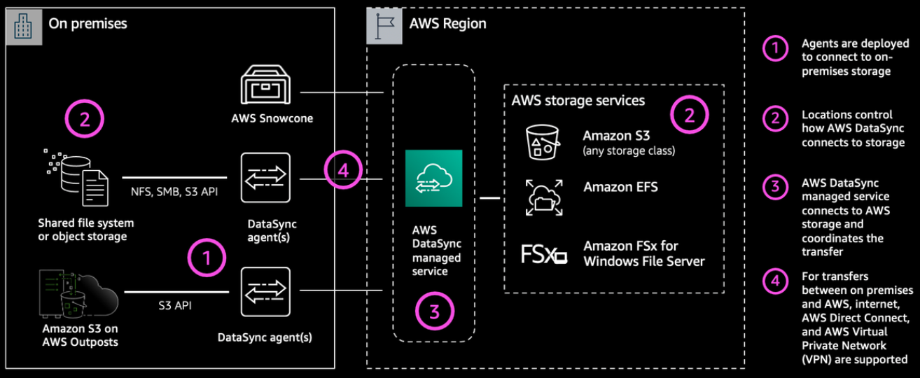

DataSync Workflow

AWS Snow Family -

The AWS snow family consists of AWS Snowcone, AWS Snowball, and AWS Snowmobile. The family consists of capacity points and physical devices that have inbuilt computing power. They help in the transportation of data both into as well as out of AWS. AWS customers can use the Snow family members for migrating data to AWS securely and cheaply.

AWS Snowcone is a portable, rugged, and secure device for edge computing and data transfer. You can use a Snowcone device to collect, process, and move data to the AWS Cloud, either offline by shipping the device to AWS, or online by using AWS DataSync.

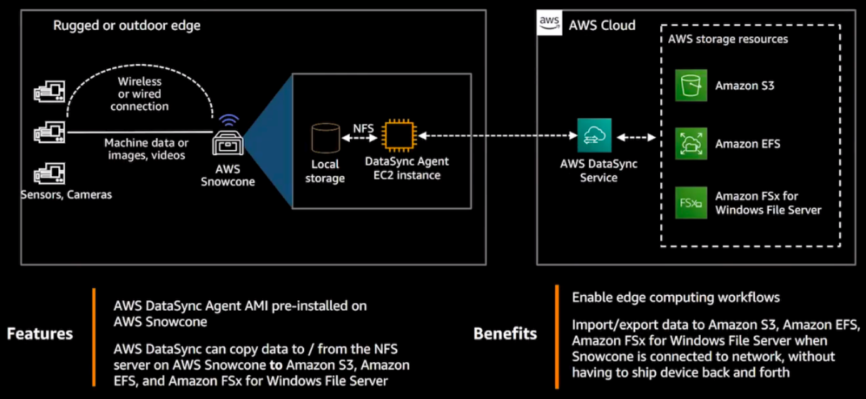

DataSync with Snowcone Workflow

Snowcone devices offer a file interface with Network File System (NFS) support. Snowcone devices support data transfer from on-premises Windows, Linux, and macOS servers and file-based applications through the NFS interface.

The AWS Snowball is an edge computing and data migration device that accelerates the migration of terabytes to petabytes of data both into and out of AWS. Snowball helps to deal with challenges associated with large-scale data migration.

Like AWS Snowball, AWS Snowcone has multiple layers of security encryption capabilities. You can use either of these services to collect, process, and transfer data to AWS, and run edge computing workloads that use Amazon EC2 instances.